Web Application Architectures

Lab 9 – Next.js ORMs and Caching

What is an ORM?
An ORM (Object-Relational Mapper or Object-Relational Mapping) is a programming technique that allows developers to interact with a relational database (like Oracle, PostgreSQL, MySQL, SQLite, etc.) using objects in their programming language, instead of writing raw SQL queries.
One object in the application maps to one tuple in the database.
For this lab we will use Prisma:
- Prisma is a next-generation ORM (Object-Relational Mapper) for Node.js and TypeScript.
- It helps to work with databases using clean, type-safe JavaScript or TypeScript code — instead of writing raw SQL.
- Prisma is the “middle layer” between the code and the database.

What is Caching?
Database caching is the process of storing frequently accessed or computationally expensive query results in a temporary storage layer (cache) for faster retrieval. Used to improve application performance and reduce database load by avoiding repetitive queries.
In Next.js, page caching refers to how the framework stores and serves pre-rendered pages to optimize performance and reduce server load. How caching works depends on the rendering mode you use — Static Generation, Server-Side Rendering (SSR), or Incremental Static Regeneration (ISR).

Application Functional Requirements:
Create a next.js application to demonstrate ORMs (Prisma) and Caching (Redis)
Create a Product catalogue to show the items for sale on our site
A product contains:
- Image
- Product name
- Product description
- Price in euros

Create a new Next App
To create a Next.js app, in the lab_8 terminal in VS Code, run the following command:
npx create-next-app@latest lab_8_app
This command uses create-next-app, a Command Line Interface (CLI) tool that sets up a Next.js application for you.
When prompted select the following options (custom setup):
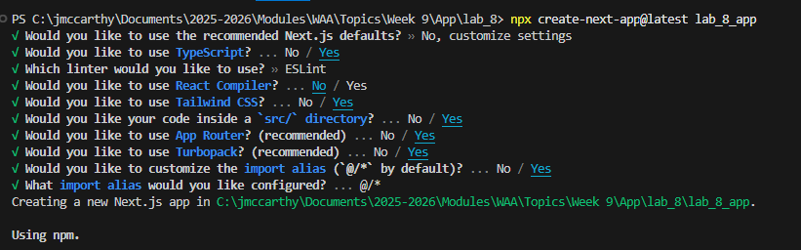
Source: https://nextjs.org/learn/dashboard-app/getting-started

Folder structure:
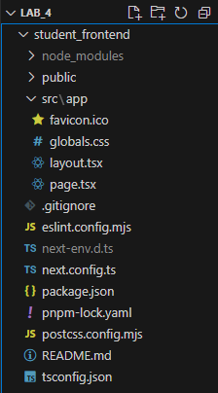 | /app: Will contain all the routes, components, and logic for your application, this is where you'll be mostly working from.  /app/lib: Contains functions used in your application, such as reusable utility functions and data fetching functions.  /app/ui: Contains all the UI components for your application, such as cards, tables, and forms.  /public: Contains all the static assets for your application, such as images.  Config Files: You'll also notice config files such as next.config.ts at the root of your application. Most of these files are created and pre-configured when you start a new project using create-next-app. You will not need to modify them in this course.

Install dependencies:
Cd into the new next app:  cd lab_8_app  npm add lucide-react | 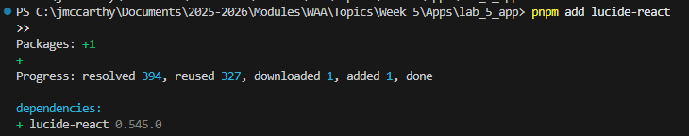

Run the server:
Run:  npm run dev | 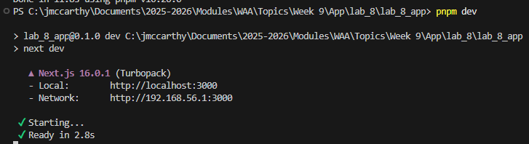

Open http://localhost:3000 on your browser. Your home page should look as follows:
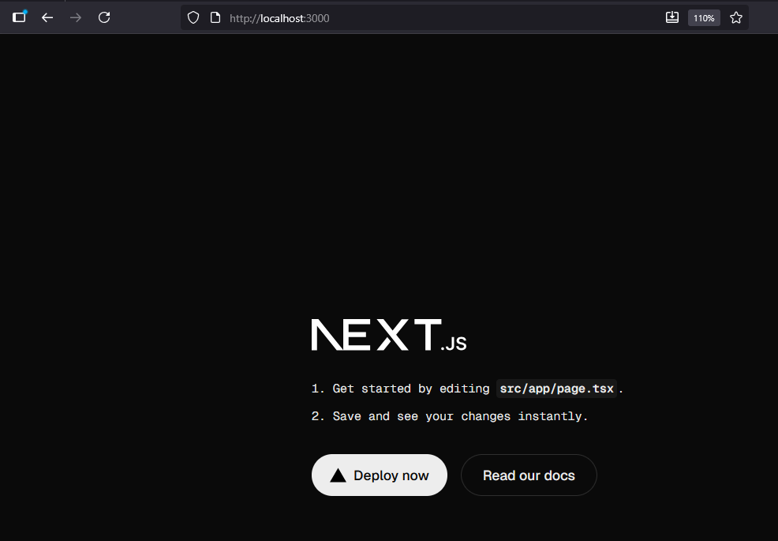

Install the project dependencies:
In terminal (project folder):
npm install prisma @prisma/client redis ioredis
npm install --save-dev typescript @types/node @types/react

prisma
- The Prisma CLI tool.
- Used to generate database clients, run migrations, and manage your Prisma schema (schema.prisma).

@prisma/client
- The auto-generated database client that Prisma creates after you run npx prisma generate.
- You import it in your code to interact with your database
- This is the ORM (Object-Relational Mapper).

redis
- The official Redis client for Node.js.
- Lets you connect and interact with a Redis server.
- We will need to install a Redis server (covered later in the lab)

ioredis
A high-performance Redis client with more features than the standard redis package.
Supports:
- Clustering
- Sentinel
- Pub/Sub
- Streams
- Pipelines
Often preferred in production apps that need advanced Redis features.

typescript (installs developer dependencies)
- Adds the TypeScript compiler (tsc).
- Lets you write type-safe code and compile .ts / .tsx files to JavaScript.

@types/node (installs developer dependencies)
- Provides TypeScript type definitions for Node.js built-in modules (like fs, path, process, etc.).
- Required so TypeScript understands Node globals in your code.

@types/react (installs developer dependencies)
- Provides TypeScript types for React (like JSX.Element, React.FC, etc.).
- Necessary if you’re using React with TypeScript.

Prisma Setup:
In terminal:
npx prisma init
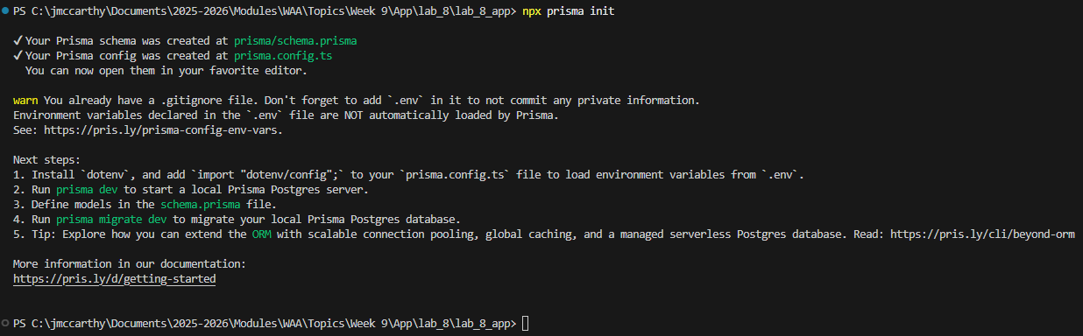
After running this command we are prompted to complete Next Steps.
Run:
npm install dotenv

Update .env file:
Update the .env file to cater for our sqlite database
DATABASE_URL="file:./dev.db"
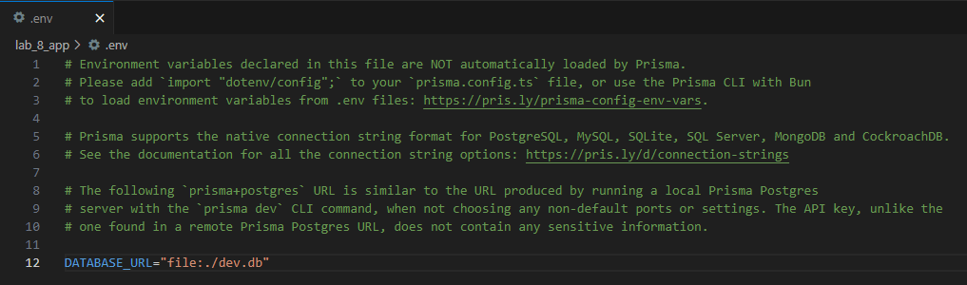

Update the Prisma config file
Go to: prisma.config.ts
Add the following to the file:
import "dotenv/config";
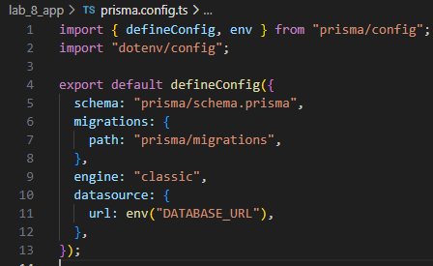

Define a Product Model:
In prisma / schema.prisma, update to look as follows:
datasource db {  provider = "sqlite" // You can use PostgreSQL or MySQL instead  url = "file:./dev.db"  }  generator client {  provider = "prisma-client-js"  }  model Product {  id Int @id @default(autoincrement())  name String  description String  price Float  image String  createdAt DateTime @default(now())  } | 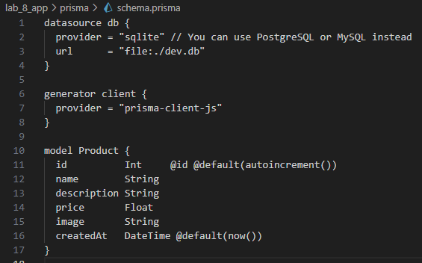

Create the SQLite database and generate Prisma client (in terminal):
npx prisma migrate dev --name init
npx prisma generate

The first command creates and applies a database migration based on changes in your schema.prisma file.
The second command generates or updates the Prisma Client in your project.

Redis Setup:
Redis is an in-memory data store often used as a database, cache, or message broker. It’s lightweight, fast, and open-source.

Step 1: Install Redis
Depending on your operating system use one of the following options.
Docker can be used to setup Redis also.
Follow the instructions below depending on you own operating system.

Install Redis on Windows:
Redis doesn’t have an official Windows port anymore, but there are reliable options:
Use Windows Subsystem for Linux (WSL)
Install WSL (Ubuntu preferred)
Open Ubuntu (from Start Menu), then run:
sudo apt update
sudo apt install redis-server -y
sudo service redis-server start
redis-cli ping

Install Redis on Mac:
If you have Homebrew installed
In terminal:
brew update
brew install redis

Start Redis service:
In terminal:
brew services start redis

Install Redis on Linux (Ubuntu/Debian)
In terminal:
sudo apt update
sudo apt install redis-server -y

Enable Redis to start on boot:
sudo systemctl enable redis-server
sudo systemctl start redis-server

Setup Redis in the Next.js project
In the project root directory create a new directory named lib.
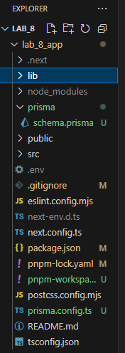

In the projects tsconfig.json file update the path to look as follows:
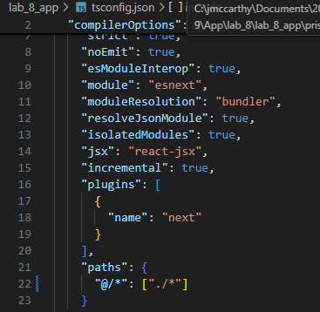

Prisma Setup:
In the lib directory create a new file named prisma.ts
import { PrismaClient } from "@prisma/client";  const globalForPrisma = global as unknown as { prisma: PrismaClient };  export const prisma =  globalForPrisma.prisma ||  new PrismaClient({  log: ["query"],  });  if (process.env.NODE_ENV !== "production") globalForPrisma.prisma = prisma; | 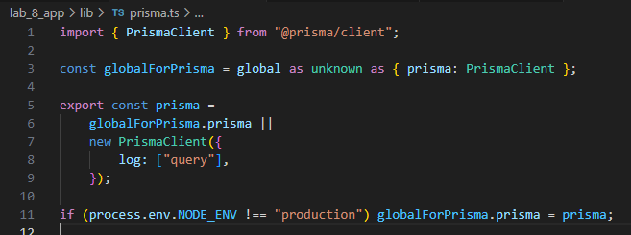

Redis Setup:
In the lib directory create a new file named redis.ts
import Redis from "ioredis";  export const redis = new Redis({  host: "127.0.0.1",  port: 6379,  }); | 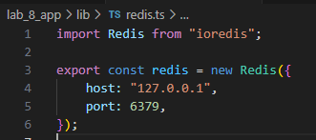
This code sets up a Redis client connection using the ioredis library. It connects to a Redis server running locally on 127.0.0.1 at the default port 6379. The exported redis object can be used throughout the application to store, retrieve, and manage data in Redis, such as caching API responses or maintaining temporary state.

Create the API Routes:
Using the App Router, we’ll define an API route inside app/api/products/route.ts.
In the app directory create the following: app/api/products/route.ts
Add the following to the route.ts file
import { NextResponse } from "next/server";  import { prisma } from "@/lib/prisma";  import { redis } from "@/lib/redis";  export async function GET() {  const cacheKey = "products";  // Try Redis cache first  const cached = await redis.get(cacheKey);  if (cached) {  console.log("Returning from cache");  return NextResponse.json(JSON.parse(cached));  }  // Otherwise, get from database  console.log("Fetching from DB");  const products = await prisma.product.findMany({  orderBy: { createdAt: "desc" },  });  // Cache for 60 seconds  await redis.set(cacheKey, JSON.stringify(products), "EX", 60);  return NextResponse.json(products);  } | 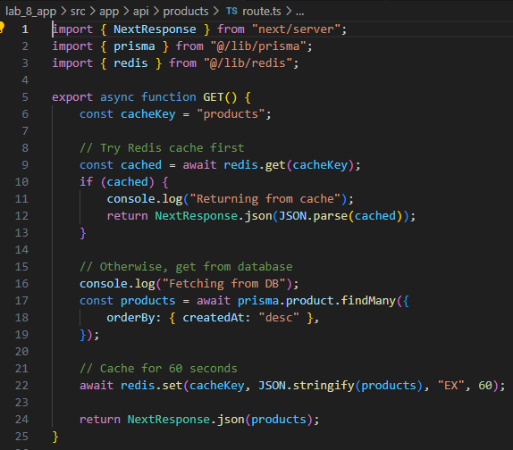

Code summary:
This function handles an HTTP GET request in a Next.js API route. It first tries to retrieve a list of products from Redis, using a cache key called "products". If the data is already cached, it immediately returns that cached response to save time and database load.
If the cache is empty, it then fetches the products from the database using Prisma, ordering them by their creation date (newest first). After fetching the data, it stores the result in Redis with a 60-second expiration so future requests can use the cache instead of querying the database again. Finally, it returns the products as a JSON response to the client.
- Check Redis cache - Return cached data if found
- Else - Query database - Cache result - Return response

Create the Product Listing Page:
In the app directory update page.tsx to look as follows:
app/page.tsx
"use client";  import { useEffect, useState } from "react";  type Product = {  id: number;  name: string;  description: string;  price: number;  image: string;  };  export default function HomePage() {  const [products, setProducts] = useState<Product[]>([]);  useEffect(() => {  fetch("/api/products")  .then(res => res.json())  .then(setProducts);  }, []);  return (  <main className="container mx-auto p-6">  <h1 className="text-3xl font-bold mb-6">Product Catalog</h1>  <div className="grid gap-6 sm:grid-cols-2 md:grid-cols-3 lg:grid-cols-4">  {products.map(p => (  <div  key={p.id}  className="border rounded-2xl shadow-sm overflow-hidden bg-white hover:shadow-md transition"  >  <img  src={p.image}  alt={p.name}  className="h-48 w-full object-cover"  />  <div className="p-4">  <h2 className="font-semibold text-lg">{p.name}</h2>  <p className="text-gray-600 text-sm mt-1">{p.description}</p>  <p className="text-green-600 font-bold mt-3">€{p.price.toFixed(2)}</p>  </div>  </div>  ))}  </div>  </main>  );  } | 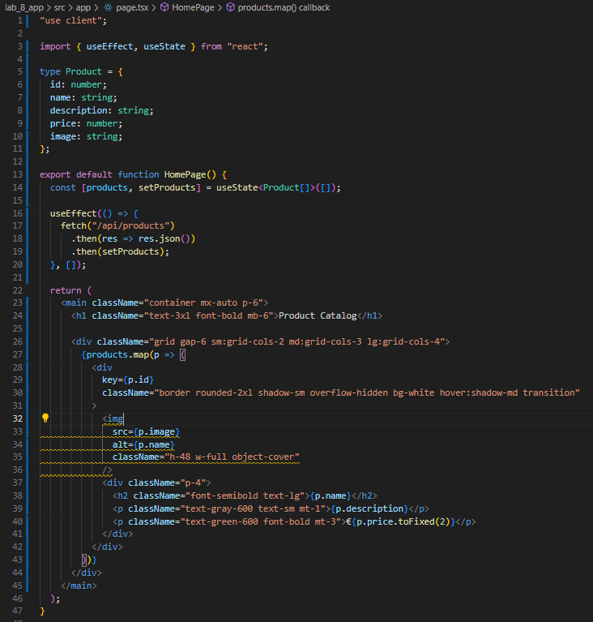

Code summary:
This React client component defines a homepage that displays a list of products in a grid layout. When the component first loads, it fetches product data from the /api/products endpoint and stores it in local state. Once the data is received, it dynamically renders each product as a styled card showing its image, name, description, and price. The layout is responsive, adjusting the number of columns based on screen size, and includes hover effects for a polished user experience.

Seed Example Products:
Create a seed script at prisma/seed.ts:
import { PrismaClient } from "@prisma/client";  const prisma = new PrismaClient();  const adjectives = [  "Elegant",  "Compact",  "Durable",  "Wireless",  "Modern",  "Smart",  "Advanced",  "Portable",  "Eco",  "Classic",  "Stylish",  "Premium",  "Budget",  "High-End",  ];  const items = [  "Headphones",  "Keyboard",  "Mouse",  "Laptop",  "Monitor",  "Camera",  "Watch",  "Phone Case",  "Charger",  "Speaker",  "Backpack",  "Tablet",  "Microphone",  "Tripod",  "Light",  "Router",  "SSD",  "USB Drive",  "Drone",  "Smart Glasses",  ];  function randomChoice<T>(arr: T[]): T {  return arr[Math.floor(Math.random() * arr.length)];  }  function randomPrice() {  return Number((Math.random() * 200 + 10).toFixed(2)); // €10–€210  }  function randomImage(id: number) {  // Use picsum.photos for placeholder images  return `https://picsum.photos/seed/${id}/400/300`;  }  async function main() {  console.log("🧹 Clearing old products...");  await prisma.product.deleteMany();  console.log("🌱 Seeding 200 products...");  const products = Array.from({ length: 200 }, (_, i) => ({  name: `${randomChoice(adjectives)} ${randomChoice(items)}`,  description: `This ${randomChoice(adjectives).toLowerCase()} ${randomChoice(  items  ).toLowerCase()} offers great performance and design.`,  price: randomPrice(),  image: randomImage(i + 1),  }));  await prisma.product.createMany({ data: products });  console.log("✅ Done seeding 200 products!");  }  main()  .catch((err) => {  console.error("❌ Error seeding:", err);  process.exit(1);  })  .finally(async () => {  await prisma.$disconnect();  }); | 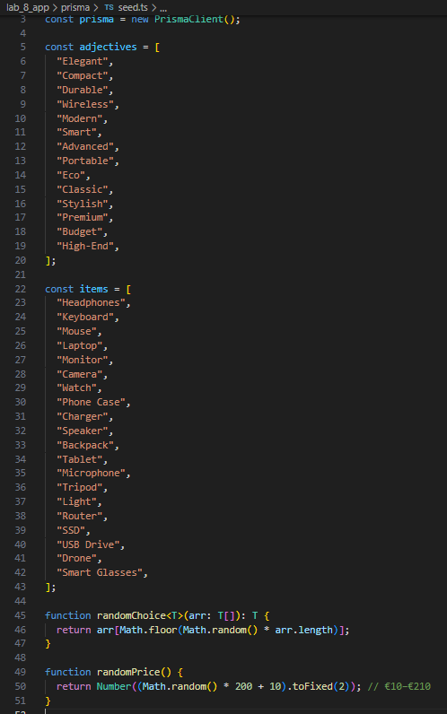  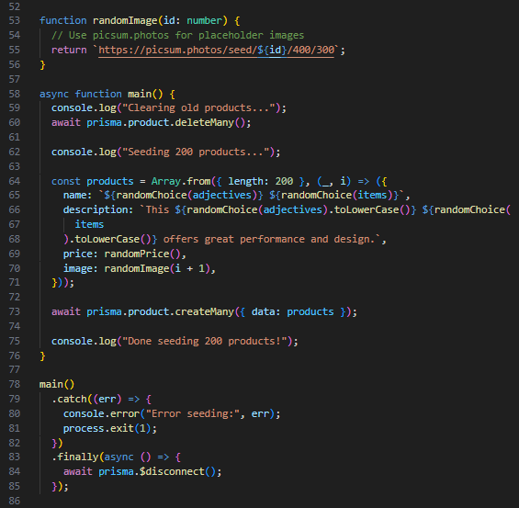

Run the seed script:
npx tsx prisma/seed.ts
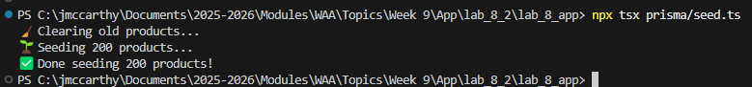
Code summary:
A seed script is a small program used to populate a database with initial or sample data. Often for testing, development, or demonstration purposes.
In this example, the script connects to the database using Prisma, clears any existing product records, and then creates 200 new sample products. Each product is given a randomly generated name, description, price, and placeholder image to make the dataset look realistic. Once the products are inserted, the script disconnects from the database.
In short, it automates the process of filling your database with meaningful mock data so your application has something to display or work with during development.

Run the App:
npm run dev
Go to: localhost:3000
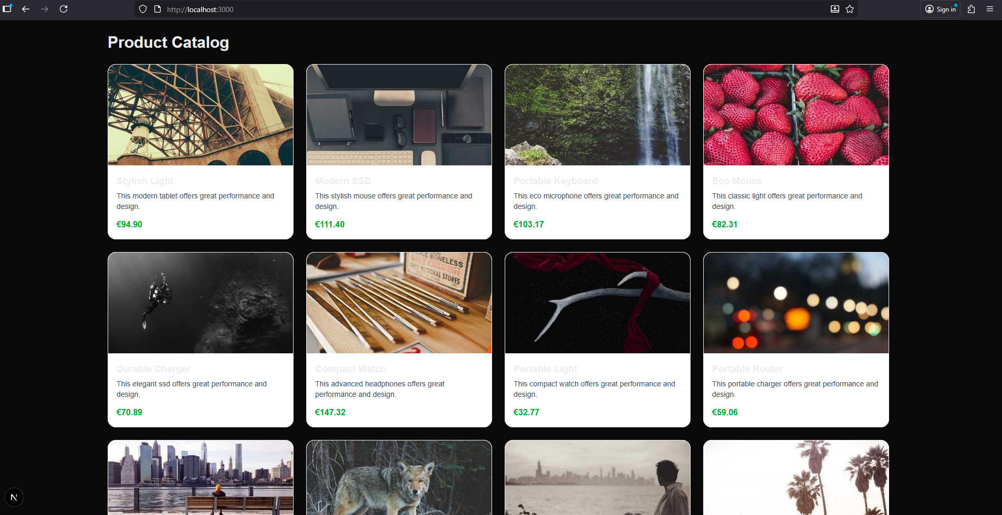

Implement Infinite Scrolling:

Update Your API Route for Pagination
We’ll modify app/api/products/route.ts to accept pagination parameters.
In the app directory refactor the route.ts file to look as follows
app/api/products/route.ts
import { NextResponse } from "next/server";  import { prisma } from "@/lib/prisma";  import { redis } from "@/lib/redis";  export async function GET(req: Request) {  const { searchParams } = new URL(req.url);  const page = Number(searchParams.get("page")) || 1;  const limit = Number(searchParams.get("limit")) || 20;  const cacheKey = `products:page:${page}:limit:${limit}`;  // Try cache first  const cached = await redis.get(cacheKey);  if (cached) {  console.log("Cache hit for", cacheKey);  return NextResponse.json(JSON.parse(cached));  }  console.log("Fetching from DB...");  const products = await prisma.product.findMany({  skip: (page - 1) * limit,  take: limit,  orderBy: { createdAt: "desc" },  });  await redis.set(cacheKey, JSON.stringify(products), "EX", 60);  return NextResponse.json(products);  } | 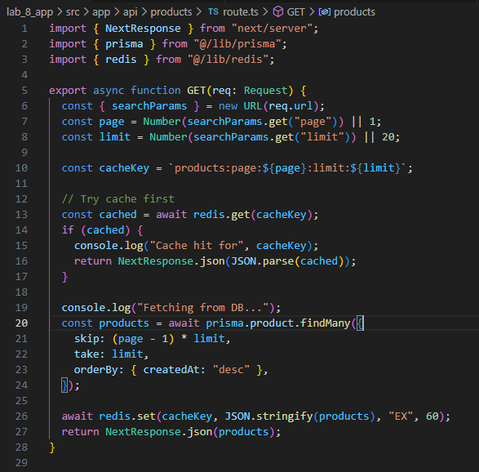

This route:
- Accepts ?page=1&limit=20 style params
- Uses Redis to cache each page separately
- Returns an array of products

Code summary:
This server function handles an HTTP GET request that supports pagination for fetching products. It reads the page and limit query parameters from the request URL to determine which set of products to return.
Before querying the database, it checks Redis to see if the requested page of products is already cached. If the cached data exists, it quickly returns that result. If not, it retrieves the appropriate products from the database using Prisma, orders them by creation date, and then stores the result in Redis with a short expiration time for future requests.
In essence, it delivers a paginated, cache-optimized API endpoint that balances speed and efficiency by reducing repeated database queries.

Update the Frontend to Use Infinite Scrolling
We’ll use the Intersection Observer API to detect when the user scrolls to the bottom and automatically fetch the next page. In Next.js (and in general web development), the Intersection Observer API is a browser API that lets you efficiently detect when an element enters or leaves the viewport, when it becomes visible (or hidden) to the user while scrolling. The Intersection Observer API observes changes in the visibility of a target element relative to a specified container or the browser’s viewport. When the visibility changes it triggers a callback function.

In the app directory refactor the page.tsx file to look as follows
app/page.tsx
"use client";  import { useEffect, useState, useRef, useCallback } from "react";  type Product = {  id: number;  name: string;  description: string;  price: number;  image: string;  };  export default function HomePage() {  const [products, setProducts] = useState<Product[]>([]);  const [hasMore, setHasMore] = useState(true);  const observer = useRef<IntersectionObserver | null>(null);  const pageRef = useRef(1);  const loadingRef = useRef(false);  const limit = 20;  // Fetch products safely using refs  const fetchProducts = useCallback(async () => {  if (loadingRef.current || !hasMore) return;  loadingRef.current = true;  try {  const res = await fetch(`/api/products?page=${pageRef.current}&limit=${limit}`);  const data: Product[] = await res.json();  setProducts(prev => [...prev, ...data]);  setHasMore(data.length === limit);  // Increment page for next fetch  pageRef.current += 1;  } catch (err) {  console.error("Error fetching products:", err);  } finally {  loadingRef.current = false;  }  }, [hasMore]);  // Initial fetch  useEffect(() => {  fetchProducts();  }, [fetchProducts]);  // Intersection Observer for infinite scroll  const lastProductRef = useCallback(  (node: HTMLDivElement) => {  if (loadingRef.current) return;  if (observer.current) observer.current.disconnect();  observer.current = new IntersectionObserver(entries => {  if (entries[0].isIntersecting && hasMore && !loadingRef.current) {  fetchProducts();  }  });  if (node) observer.current.observe(node);  },  [fetchProducts, hasMore]  );  return (  <main className="container mx-auto p-6">  <h1 className="text-3xl font-bold mb-6">Product Catalog</h1>  <div className="grid gap-6 sm:grid-cols-2 md:grid-cols-3 lg:grid-cols-4">  {products.map((p, idx) => {  const isLast = idx === products.length - 1;  return (  <div  ref={isLast ? lastProductRef : null}  key={`${p.id}-${idx}`} // unique key  className="border rounded-2xl shadow-sm overflow-hidden bg-white hover:shadow-md transition"  >  <img src={p.image} alt={p.name} className="h-48 w-full object-cover" />  <div className="p-4">  <h2 className="font-semibold text-lg">{p.name}</h2>  <p className="text-gray-600 text-sm mt-1">{p.description}</p>  <p className="text-green-600 font-bold mt-3">€{p.price.toFixed(2)}</p>  </div>  </div>  );  })}  </div>  {loadingRef.current && (  <p className="text-center mt-6 text-gray-500">Loading more products...</p>  )}  {!hasMore && !loadingRef.current && (  <p className="text-center mt-6 text-gray-400">No more products!</p>  )}  </main>  );  } | 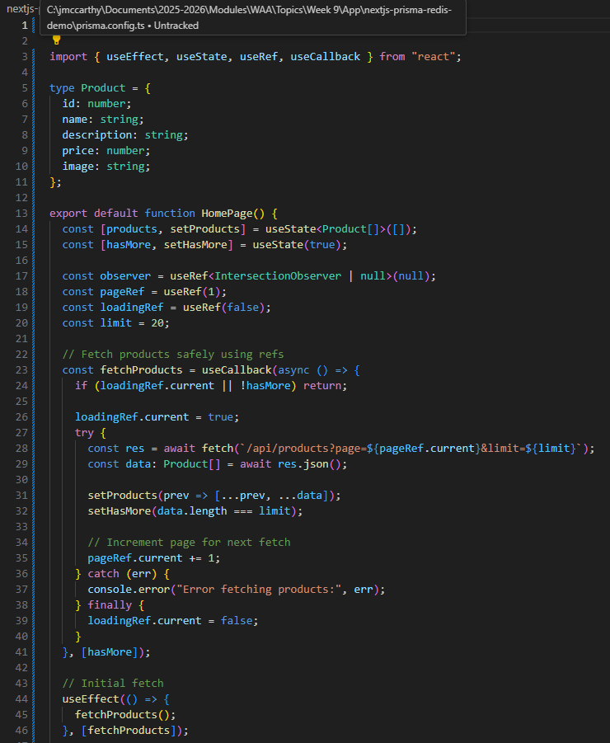  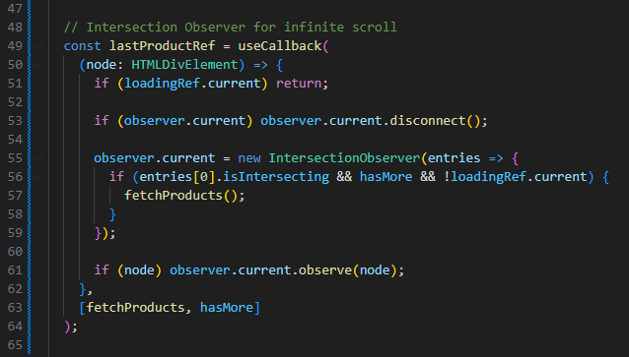  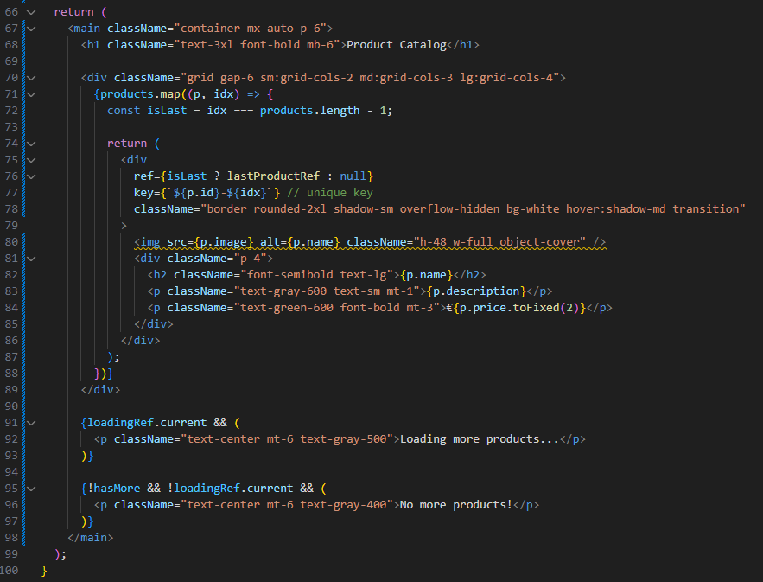

This client component:
- Starts by fetching the first page (page=1)
- Observes the last product card to trigger the next page load
- Keeps appending new results to the list
- Stops when no more products are available

Code summary:
This component is a client-side Next.js page that displays a product catalog with infinite scrolling. It maintains a list of products in state and fetches additional products from an API endpoint as the user scrolls down.
Key points:
- State management: Tracks the loaded products and whether more products are available.
- Infinite scroll: Uses the Intersection Observer API to detect when the last product is visible, then triggers a fetch for the next page.
- Fetch control: Uses refs to track the current page and loading state, ensuring that requests are not duplicated and each page is fetched only once.
- Rendering: Displays products in a responsive grid, showing images, names, descriptions, and prices, with a loading indicator and a message when no more products are available.
- Performance & stability: Ensures unique keys for list items and avoids cascading renders by managing state updates safely.
- In short, it provides a smooth, paginated product listing that loads data incrementally as the user scrolls.

Run the app:
npm run dev
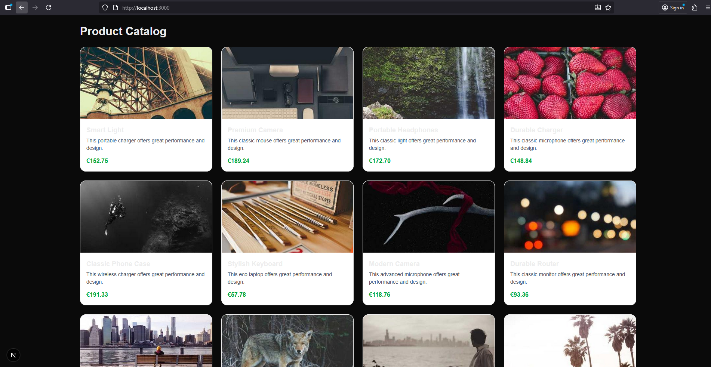
Scroll down, additional content should load and appear

